**IoT Temperature Sensor**

The aim was to design a device that can sense temperature of the environment and can periodically upload temperature data to a server on a cloud.

Few features of the device should be:

* Small
* Powered with lithium polymer cell
* Energy efficient
* WiFi Enabled

Components Used:

* TP4056 Module for LIPO battery charging and protection
* ATmega328P – AU (TQFP package for smaller size)
* Boost Converter of 5VDC output
* AMS1117 IC (3.3V linier voltage regulator for WiFi module)
* ESP-01 (ESP8266 based WiFi module)
* LM35 – Temperature sensor
* Lithium Polymer battery (1s)

Schematic Design (In Eagle PCB):

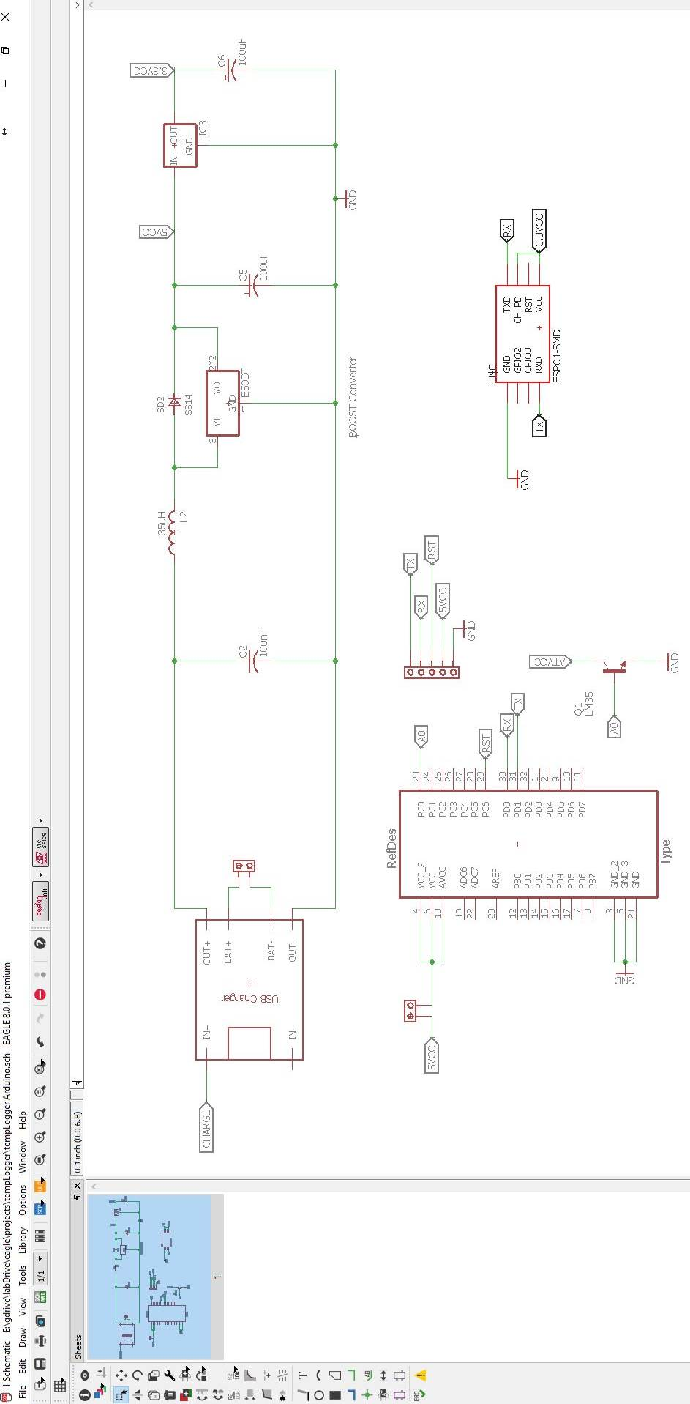

PCB Design (In Eagle PCB):

F

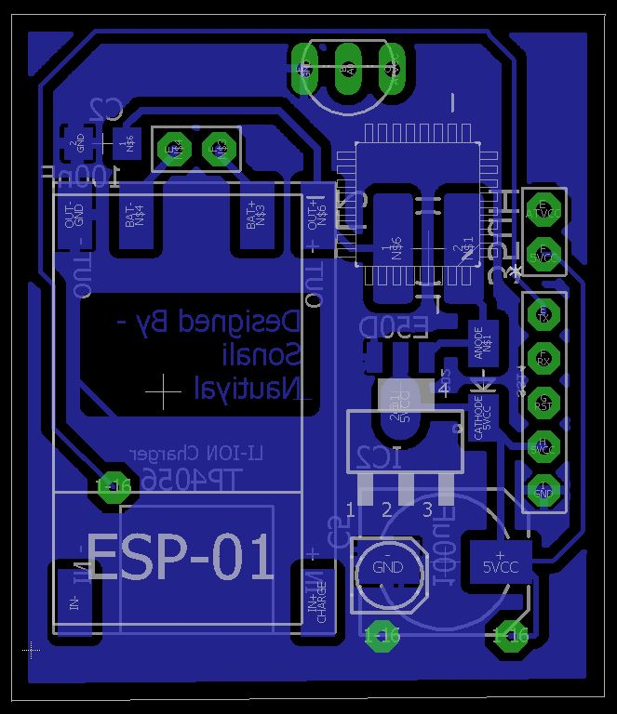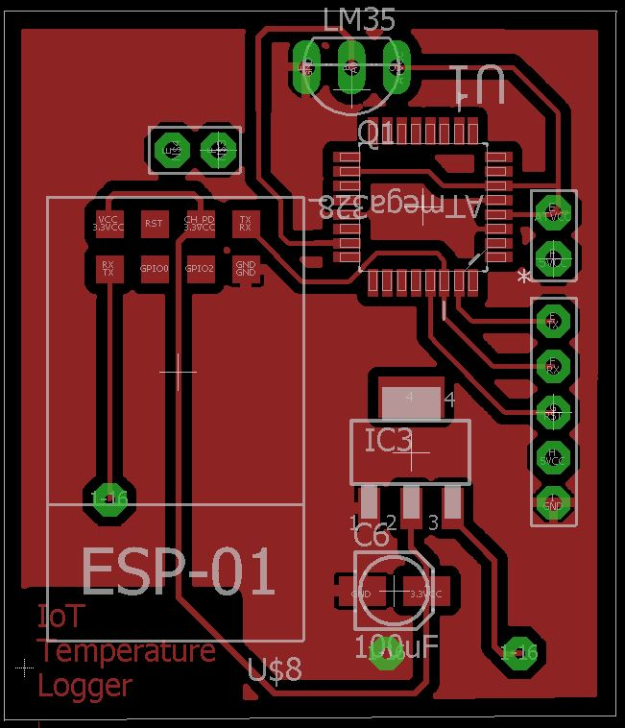

|  |  |
| --- | --- |
| Fig: Bottom Layer | Fig: Top Layer |

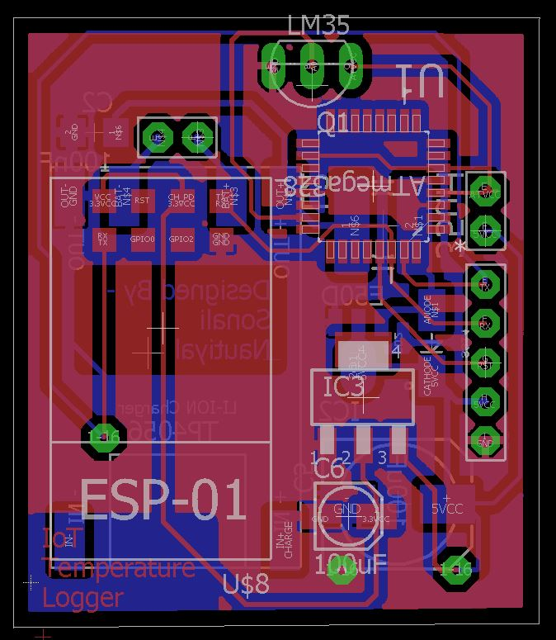

Fig: Dual Layer Design for compact size

PCB Fabrication:

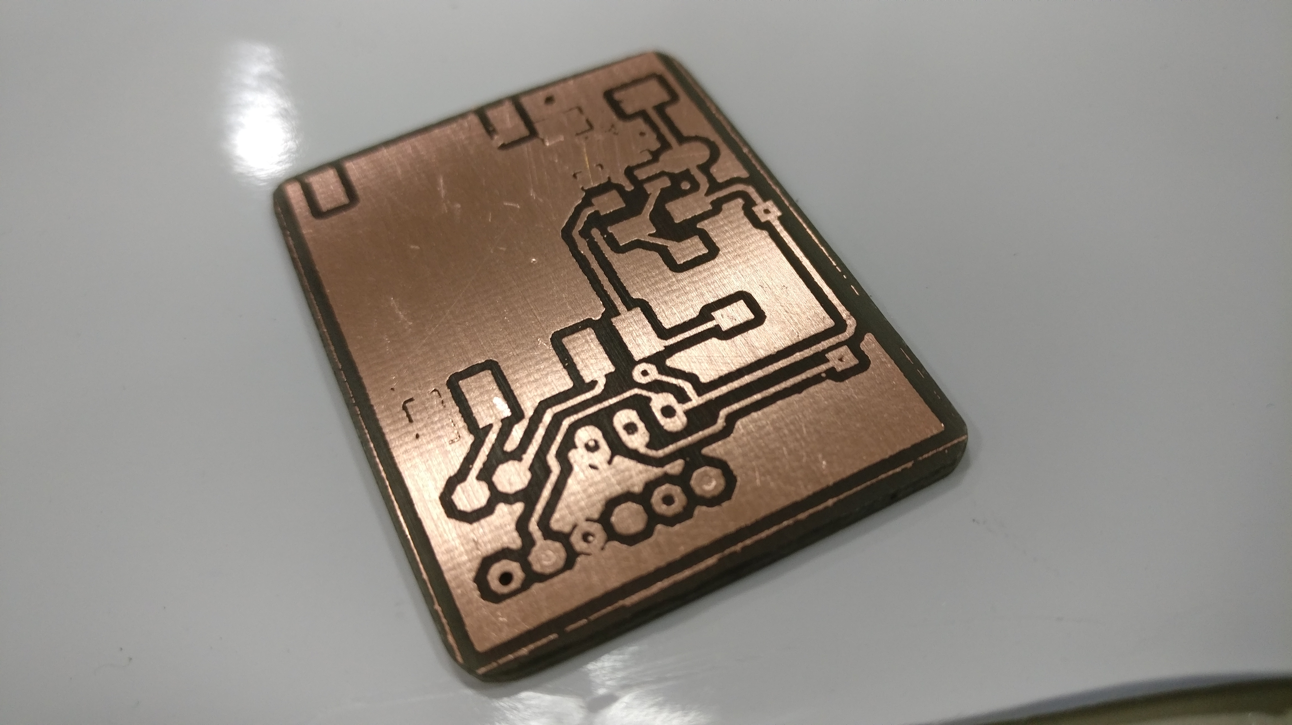

Fig: PCB after etching in ferric chloride (Unpopulated)

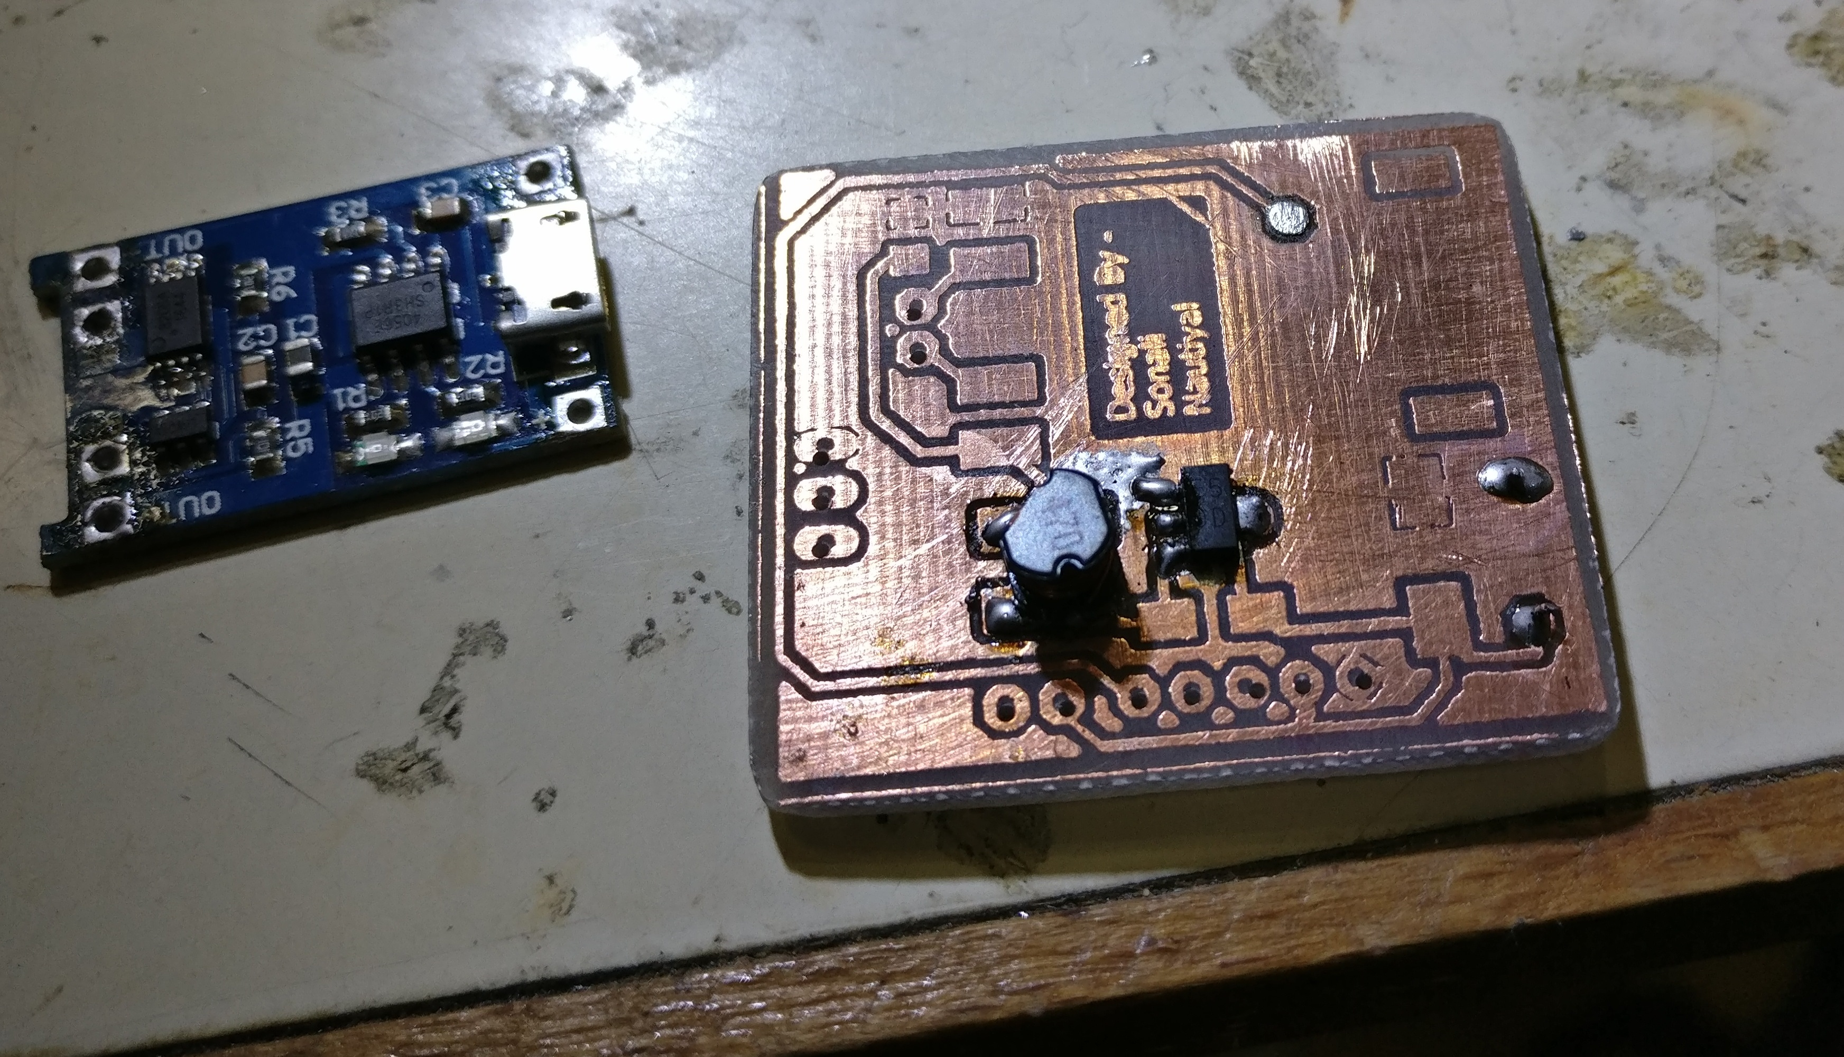

Fig: Soldering SMD components onto the PCB

The Final Device:

ATmega328P - TQFP

WiFi Module

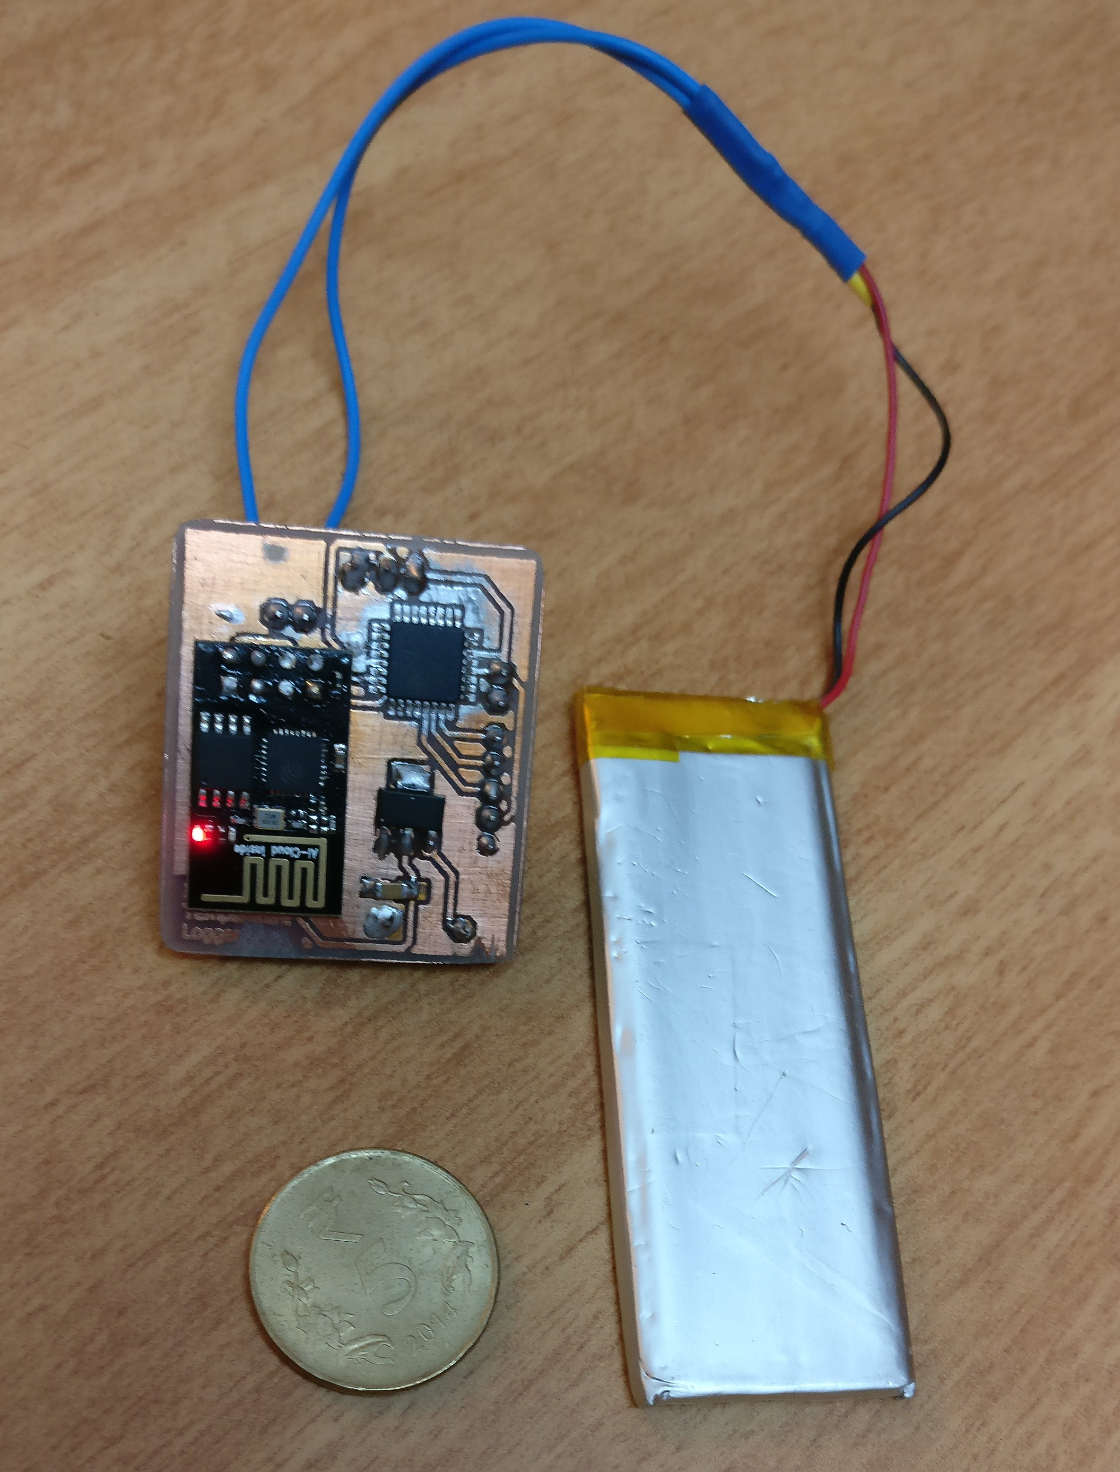

LM35

Temp.

Sensor

LiPo

Battery

TP4056

Battery

Charger

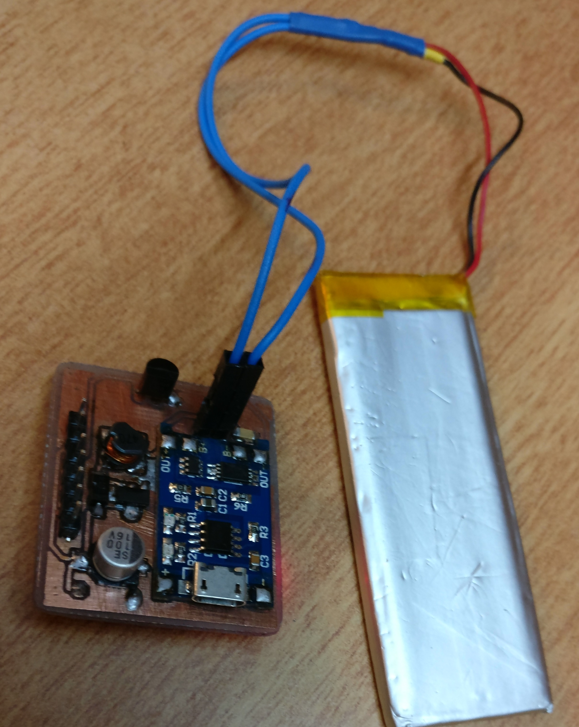

Could Access:

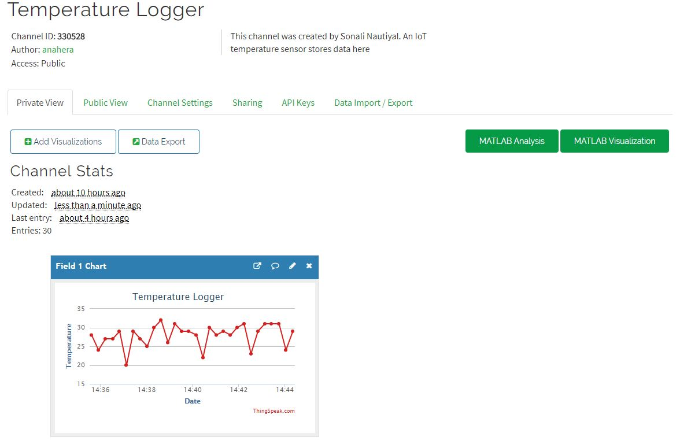

Fig: Accessing real-time temperature data stored in could server

Public Access Link:

https://thingspeak.com/channels/330528